Architecture Solution Design

[Multi-Cloud Networking Solution Design]

[RITM0902674| ACBSD-3278]

Version Control
Version Control |  |  |  |  | Approvals
Version | Date | Author/  Updated By: | Status | Comment | Pre-ARB | GTS ARB | Global ARB | GITB
01.00.00 | 2025-21-DD | Bobby Willoughby | Initial Document | This is a document detailing how Aegon is using various components to provide a resilient, highly available and secure multi-cloud network | ☐ | ☐ | ☐ | ☐
 |  |  | Choose an item. |  | ☐ | ☐ | ☐ | ☐
 |  |  | Choose an item. |  | ☐ | ☐ | ☐ | ☐
 |  |  | Choose an item. |  | ☐ | ☐ | ☐ | ☐
 |  |  | Choose an item. |  | ☐ | ☐ | ☐ | ☐
 |  |  | Choose an item. |  | ☐ | ☐ | ☐ | ☐
 |  |  | Choose an item. |  | ☐ | ☐ | ☐ | ☐

Table of Contents
Version Control 1
Table of Contents 3
1. Distribution and Contacts 6
2. Summary 7
2.1 Background 7
2.2 Solution Description 7
2.3 Business Unit(s) Impacted 8
3. Requirements 9
3.1 Use Cases 9
3.1.1 Business Requirements 9
3.2 Functional Requirements 10
3.3 Non-Functional Requirements 11
3.4 Security Requirements 12
3.5 Data Requirements 13
3.6 Capability Map 14
4. Architecture 15
4.1 Alignment to Principles 15
4.2 Baseline Architecture 16
4.3 Target Architecture 17
4.3.1 High-Level Overview 17
4.3.1 Detailed Overview 18
4.3.1 Deeper Detailed Overview 19
4.3.2 Technology Components & Architecture Impacts 20
4.3.3 Gap Analysis 20
5. Components 20
5.1 Components or Patterns Used 20
5.1.1 Component Architecture Diagram 21
5.1.2 Components or Pattern Table 21
5.2 Integration Architecture 22
5.2.1 Integration Architecture Diagram 22
5.2.2 Integration Architecture Table 22
5.3 Data Flow 23
5.3.1 Data Flow Diagram 23
5.3.2 Data Flow Table 23
5.4 Data Protection 24
5.4.1 Backup and Recovery 24
5.4.2 High Availability 24
5.4.3 Disaster Recovery 24
5.5 Observability 24
5.6 Authentication and Authorization 25
5.7 Security Boundaries 25
5.7.1 Security Boundaries Diagram 25
5.7.2 Security Boundaries Table 25
5.7.3 Security Review Outcomes 25
5.7.4 Threat Model Assessment 25
5.8 Resiliency 26
6. Data Solution 27
6.1 Data Classification 27
6.2 Privacy Impact Assessment (PIA) 27
6.3 Data Encryption 27
6.4 Data Retention 27
6.5 Data Residency 27
6.6 GenAI (Future v.3) 27
7. Service Model 28
7.1 Shared Responsibilities 28
7.2 RACI Chart 28
8. Implementation Approach 30
8.1 Proposed level of coordination 30
8.2 Dependencies 30
9. Licensing 30
10. Artifacts 31
11. Waivers and/or Exceptions 32
11.1 Risk Acceptances 32
11.2 Risk Remediations 32
11.3 Security Exceptions 32
12. Estimated Costs 34
12.1 Financial Considerations 34
12.2 Non-Financial Considerations 34
12.3 Financial Assumptions 34
12.4 Resourcing Considerations 34
13. Exit Strategy 35

Distribution and Contacts
This document and future updates to be shared with the business representatives shown below.
Business Contacts and Information
Requester
Business DPO
Business ISO
Business Architect
BCP Manager
Business Unit
Cost Center
Cost Center Owner
Product / Service Owner
GTS Contacts and Information
GTS DPO | Adam Kaminski
GTS ISO | Nick Russell & Daniel Lartey
GTS Architecture | Bobby Willoughby
GTS Technology Risk Assessment | Rachel Singewald

Summary

Background
For the purposes of this document multi-cloud networking is defined as any connectivity between private clouds, data centers, between regions and environments. This document will describe how Aegon is choosing to implement multi-cloud connectivity to provide a highly secure, reliable, scalable and cost-effective service to the businesses. It will also highlight how Aegon is using a hub-n-spoke model to centralize security and visibility for each cloud/region/environment. The connectivity described in this design, is only needed to provide connectivity between GTS-managed data centers/transit networks used to route traffic for Aegon (Hubs). In other words, we do not use the components in this design to provide direct connectivity to/from/between business VPCs, VNETs, or Datacenters environments (Spokes).
This document is a retrospective document of the existing implementation and not a recommendation for a new architecture.

Solution Description
This solution will describe how the following components/technologies are used to provide multi-cloud connectivity. This network is secure (private and encrypted), resilient and highly automated.
- Network Encryption
  - Aviatrix
- Private, Cloud Native Networking
  - AWS DirectConnect
  - Azure Express Route
- Service Provider WAN Connectivity
  - AT&T MPLS
- Service Provider Internet Connectivity
  - AWS Internet
  - AT&T Internet
  - Azure Internet
  - Lumen Internet
- Virtual Private Networking
  - VPN for Disaster Recovery connectivity
- Virtualized Cloud Connectivity and Orchestration
  - AT&T Netbond
In general, data centers use multiple MPLS circuits over the AT&T backbone to connect to AT&T Netbond. AT&T Netbond is a highly virtualized service that provides connectivity to virtually every cloud provider in every region. Netbond is uses fiber connectivity (cross connect) to gain access to components like Azure ExpressRoute Circuits and AWS DirectConnect services to provide private connectivity to Azure VNETs and AWS VPCs. All of this is segmented from the CSP to the data center using VLANs, VRF’s and other virtualization technology to keep production and non-production traffic separate. MPLS and Netbond do not provide network encryption, so we use Aviatrix as an overlay on top of the network to provide encryption between the data centers and clouds. The same technology used to encrypt this traffic is also used to encrypt traffic between production and non-production, AWS and Azure, and multiple regions.

Business Unit(s) Impacted
The following Country/Business Unit(s) will be impacted by this Solution Design:
☐ | TA Individual | ☐ | Spain
☐ | TA Workplace | ☐ | HR Global
☐ | TA Finance | ☐ | ASIA/TLB
☐ | TA | ☐ | Corporate Centre
☐ | UK | ☐ | AAM
☐ | NL | ☐ | Other (Specify) _________________
☒ | GTS | ☒ | Global

Requirements

Use Cases

Key Objectives
- Provide secure/resilient connectivity between the physical data centers and AWS/Azure private networks
- Provide secure/resilient connectivity between AWS and Azure
- Provide secure/resilient connectivity between Production and Non-Production Environments
Scope
Deploy an architecture that can meet the needs of all the key objectives in a cost-effective manner

Business Requirements

Business Requirements
Req. # | Requirement Details | Priority
BR. 1.0 | Security and Compliance:  - Data encryption in transit and at rest, adhering to industry standards and regulations (e.g., HIPAA, PCI-DSS, GDPR)  - Secure communication channels between different cloud environments and on-premises data centers  - Identity and access management (IAM) for controlling and auditing access to resources across clouds  - Compliance with industry-specific regulations and internal security policies | Must Have
BR. 2.0 | High Availability and Fault Tolerance  - Redundant connectivity paths between different cloud environments and on-premises data centers  - Failover mechanisms to ensure continuity in case of failures or outages | Must have
BR. 3.0 | Performance and Latency  - Low-latency connectivity between different environments to support real-time applications and data replication  - Optimized data transfer rates for large-scale data migrations or synchronization  - Caching and content delivery mechanisms to enhance performance for end-users | Should have
BR. 4.0 | Scalability and Flexibility:  - Ability to scale connectivity bandwidth and resources as per changing business demands  - Flexibility to integrate with new cloud providers or on-premises data centers in the future  - Support for hybrid and multi-cloud workload deployments | Must have
BR. 5.0 | Manageability and Visibility:  - Centralized management and monitoring of the multi-cloud network infrastructure  - End-to-end visibility and analytics for network traffic, performance, and security events  - Automated provisioning and configuration management for network resources | Should have
BR. 6.0 | Cost Optimization:  - Cost-effective connectivity solutions, considering bandwidth usage, data transfer rates, and resource utilization  - Ability to leverage cloud provider's native networking services and pricing models  - Optimization of resource usage and cost across multiple cloud environments | Must have

Functional Requirements
Functional Requirements
Req. # | Req. Category | Requirement Details | Priority
FR.1.0 | Connectivity | Establish secure and reliable connectivity between on-premises data centers, private AWS networks, and private Azure networks. | Must Have
FR.2.0 | Data Transfer | Enable efficient and secure data transfer between different cloud environments and on-premises data centers. | Must Have
FR.3.0 | Routing and Failover | Implement intelligent routing mechanisms and failover capabilities to ensure high availability and fault tolerance. | Must Have
FR.4.0 | Load Balancing | Provide load balancing capabilities to distribute traffic across multiple connections and optimize resource utilization | Should Have
FR.5.0 | Integration | Support integration with existing on-premises infrastructure, as well as cloud-native services and applications | Must Have
FR.6.0 | Automation/Orchestration | Enable automated/orchestrated provisioning, configuration, and management of network resources across multiple cloud environments | Must Have

Non-Functional Requirements
Non-Functional Requirements
Req. # | Req. Category | Requirement Details | Priority
NFR.1.0 | Security | Implement robust security measures, such as data encryption (in transit and at rest), secure communication channels, identity and access management, and compliance with industry regulations and internal security policies | Must Have
NFR.2.0 | Performance | Ensure low-latency connectivity, optimized data transfer rates, and efficient caching and content delivery mechanisms to meet performance requirements | Must Have
NFR.3.0 | Scalability | Provide the ability to scale connectivity bandwidth and resources dynamically to accommodate changing business demands | Must Have
NFR.4.0 | Availability | Achieve high availability and fault tolerance through redundant connectivity paths, failover mechanisms, and automated recovery | Must Have
NFR.5.0 | Manageability | Offer centralized management, monitoring, and visibility of the multi-cloud network infrastructure, including end-to-end traffic analytics and automated provisioning capabilities | Must Have
NFR.6.0 | Cost Optimization | Implement cost-effective connectivity solutions, leverage cloud providers' native networking services and pricing models, and optimize resource utilization and cost across multiple cloud environments | Must Have
NFR.7.0 | Flexibility | Support hybrid and multi-cloud workload deployments and provide the flexibility to integrate with new cloud providers or on-premises data centers in the future | Must Have
NFR.8.0 | Interoperability | Ensure interoperability and compatibility with existing systems, applications, and cloud services across different cloud environments | Must Have

Security Requirements

Security Requirements
Req. # | Req. Category | Requirement Details | Priority
SR.1.0 | Security Requirement | End-to-end encryption of data in transit across all network connections between on-premises data centers, private AWS networks, and private Azure networks | Must Have
SR.2.0 | Security Requirement | Establishment of secure network boundaries and segmentation using virtual private clouds (VPCs) or virtual networks (VNets). | Must Have
SR.3.0 | IAM | Implementation of a centralized identity management system for authentication and authorization across multiple cloud environments and on-premises data centers. | Should Have
SR.4.0 | IAM | Integration with existing on-premises identity providers (e.g., Active Directory, LDAP) or cloud-based identity services | Should Have
SR.5.0 | Monitoring and Logging | Centralized logging and monitoring of security events, network traffic, and system activities across all environments.  Integration with Security Information and Event Management (SIEM) solutions for real-time threat detection and incident response | Must Have
SR.6.0 | Secure DevOps | Implementation of secure software development practices, such as code reviews, static code analysis, and secure coding guidelines | Should Have
SR.7.0 | Compliance and Governance | Adherence to industry-specific regulations and standards (e.g., HIPAA, PCI-DSS, GDPR) for data handling, storage, and processing.  Implementation of security governance policies and procedures for risk management, change management, and incident response.  Regularly scheduled security audits and assessments to identify and mitigate potential vulnerabilities | Must Have

Data Requirements
Data Requirements
Req. # | Req. Category | Requirement Details | Priority
DR.1.0 | Data Requirement | Data is encrypted in transit | Must Have
DR.2.0

Capability Map
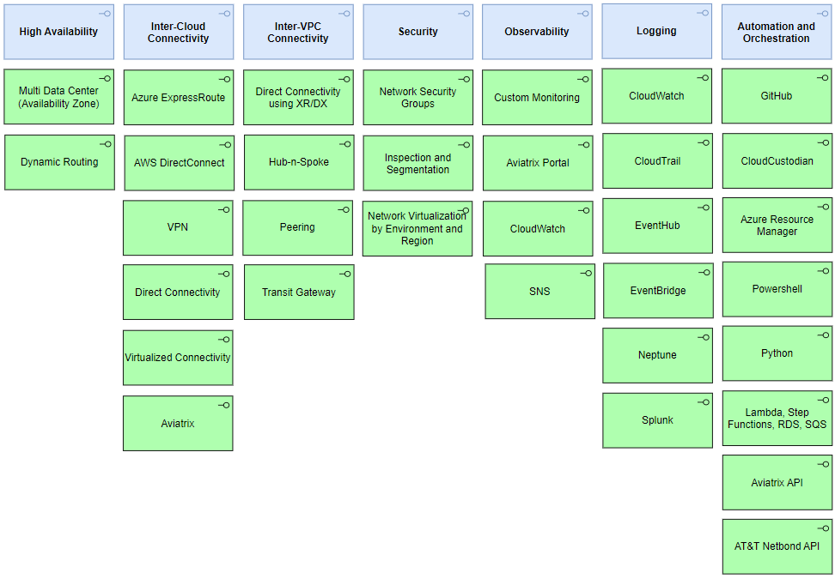

Architecture

Alignment to Principles
Architecture Principles (sharepoint.com)
Architecture Principles Alignment |  | Justification for lack of alignment (or a comment)
☒ | Capability Driven
☒ | Data as an Asset
☒ | Secure and Compliant
☒ | Transparent and Measurable
☒ | Future Fit
☒ | Reliable and Scalable
☒ | Interoperable and Integrated
☒ | Standardized
☒ | Value and Cost Oriented

Baseline Architecture
This is an initial document describing the current environment. There is no baseline for comparison.

Target Architecture

High-Level Overview
Connectivity from the production data centers to the cloud will be provided over an MPLS network connected to AT&T. AT&T provides a highly virtualized environment called Netbond that allows Aegon to provision connectivity to virtually any cloud in any region. All components are redundant and BGP is used for path failover between redundant paths. Within the cloud environment highly available, scalable and redundant infrastructure is used to connect to private networks; with components spread across multiple data centers (availability zones). For Disaster Recovery data centers, we use VPN connectivity instead of Netbond over DirectConnect/ExpressRoute.
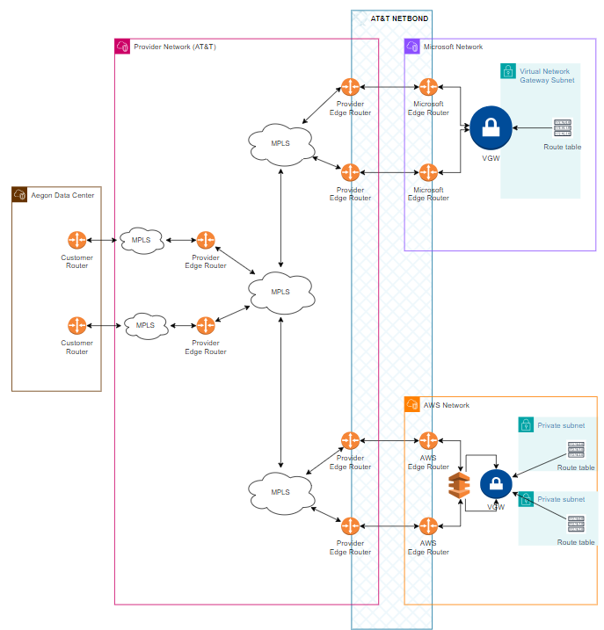

Detailed Overview
In this view we see the redundancy of each component and how we use a hub-n-spoke architecture in Azure and AWS to provide connectivity to private networks through a centralized inspection network.
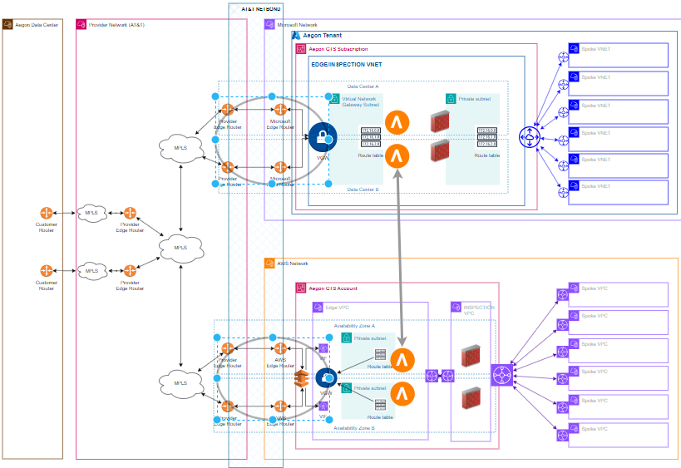

Deeper Detailed Overview
Azure ExpressRoute (XR) | AWS DirectConnect (DX)
In this view we see greater detail of how XR is delivered from the provider edge through Azure to the private network using a Virtual Network Gateway. The VGW uses a dedicated subnet for connectivity and routing over XR. | In this view we see greater detail of how DX is delivered from the provider edge through AWS to the private network using a Virtual Network Gateway. The VGW in AWS does not require a dedicated subnet, it does not require a subnet at all as it operates at the VNET level.
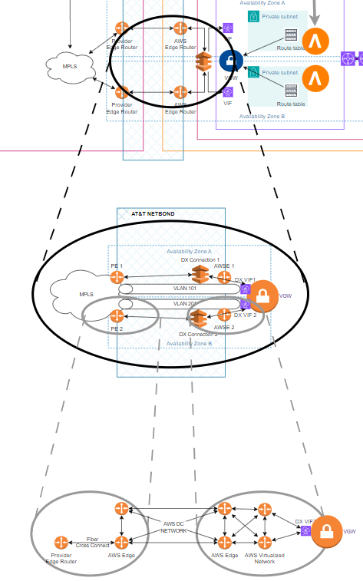
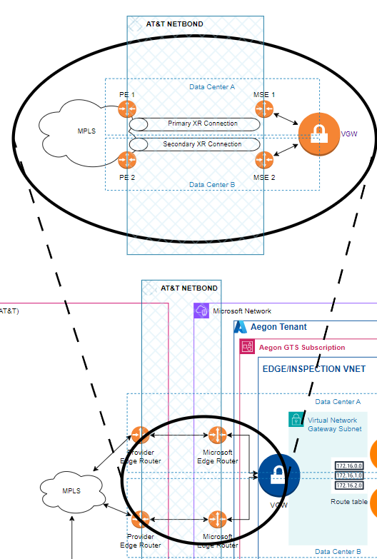
Figure 1 AWS DirectConnect (DX)
Figure 2 Azure ExpressRoute (XR)

Technology Components & Architecture Impacts
List the technology components impacted by the change.

Technology Component Type | Technology Component Name | CMDB ID | Architecture Impact | Tech Lifecycle Strategy | Application Risk Rating
Application | AT&T Netbond | APM0001337 | Reuse | Hold/Maintain | LOW
Application | AT&T MPLS
Cloud Component | Azure ExpressRoute Circuit
Cloud Component | AWS DirectConnect
Cloud Component | Virtual Network Gateway
Cloud Component | AWS Transit Gateway
Cloud Component | Azure VNET Peering
Cloud Component | Aviatrix Edge Gateway | APM0001079 | Reuse | Buy/Invest | LOW

Gap Analysis
N/A

Components

Components or Patterns Used
This will include the logical high-level architecture diagram based on the previous contextual diagram and a list of components used in the solution (use links when possible).
GTS Component Architecture Standards (sharepoint.com)
GTS Reference Architectures (sharepoint.com)
GTS Architectural Patterns (sharepoint.com)

Component Architecture Diagram
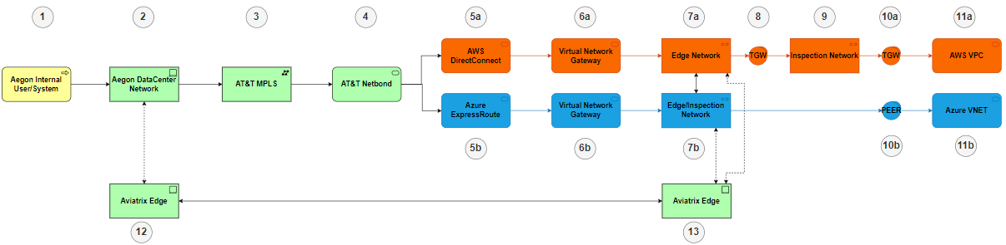

Components or Pattern Table
Components/Patterns Used |  | Version
1 | Typical Aegon internal User or System
2 | Data Center Network
3 | MPLS Network Backbone and Local Circuits
4 | AT&T Netbond Cloud Virtual Network
5a | AWS DirectConnect
5b | Azure ExpressRoute
6a | AWS Virtual Network Gateway
6b | Azure Virtual Network Gateway
7a | AWS Edge VPC
7b | Azure Edge and Inspection VNET
8 | AWS Transit Gateway
9 | AWS Inspection VPC
10a | AWS Transit Gateway
10b | Azure VNET Peering
11a | AWS VPC
11b | Azure VNET
12 | Aviatrix Edge Appliance (VM)
13 | Aviatrix Cloud Virtual Appliance

Integration Architecture

Integration Architecture Diagram
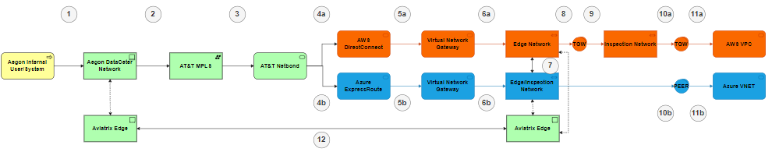

Integration Architecture Table
 | Source Component | Target Component | Purpose | Security Integration Pattern
1 | Internal System | DataCenter Network | Communication to Cloud | General TCP/IP over traditional network
2 | DataCenter Network | AT&T MPLS | Communication to Cloud | General TCP/IP over WAN links
3 | AT&T MPLS | AT&T NETBOND | MPLS Pathway to Cloud | Netbond Virtual Cloud Connectivity and Orchestration
4a | AT&T NETBOND | AWS DirectConnect | Virtualized Cloud Connectivity | Cross Connects and Multi VLAN Configuration
4b | AT&T NETBOND | Azure ExpressRoute | Virtualized Cloud Connectivity | Cross Connects and Multi VLAN Configuration
5a | AWS DirectConnect | Virtual Network Gateway | DX Connection to VPC | AWS Managed
5b | Azure ExpressRoute | Virtual Network Gateway | XR Connection to VNET | Azure Managed
6a | Virtual Network Gateway | AWS Edge VPC | DX Connection to VPC | AWS Managed
6b | Virtual Network Gateway | Azure Edge/Inspection VNET | XR Connection to VNET | Azure Managed
7 | AWS Edge VPC | Azure Edge/Inspection VNET | Inter-Cloud Connectivity | Aviatrix High Performance Routing over Public Infrastructure
8 | AWS Edge VPC | AWS Transit Gateway | Connectivity between VPCs | AWS Managed
9 | AWS Transit Gateway | AWS Inspection VPC | Connectivity between VPCs | AWS Managed
10a | AWS Inspection VPC | AWS Transit Gateway | Connectivity between VPCs | AWS Managed
10b | Azure Edge/Inspection VNET | Azure Peering | Connectivity between VNETs | Azure Managed
11a | AWS Transit Gateway | Spoke VPC | Connectivity between VPCs | AWS Managed
11b | Azure Peering | Spoke VNET | Connectivity between VNETs | Azure Managed
12 | Aviatrix Edge | Aviatrix Edge | Encrypted Traffic | Encrypted Traffic

Data Flow

Data Flow Diagram


Data Flow Table
Data Flow Reference |  | Description
1 | General TCP/IP Traffic | General TCP/IP Traffic
2-6 | Aviatrix Tunnel Traffic | Encrypted Tunnels
7 | General TCP/IP Traffic | Everything is by-directional (Encrypted).
8-11 | Private Cloud Traffic | Private Cloud Traffic
12 | General TCP/IP Traffic | Everything is by-directional (Encrypted).

Data Protection

Backup and Recovery
IaC is backed up in GitHub
Aviatrix is backed up in S3
Firewalls are backed up in Panorama
Network Switches/Routers are backed up on Unix Server and NetBrain

High Availability
All components are redundant within each supported region. Some are Active/Active while other are Active/Passive

Disaster Recovery
Support for DR connectivity is included. DR connectivity may not be identical to production (e.g. Internet-based VPN versus DirectConnect/Netbond), but the communication capabilities are consistent.
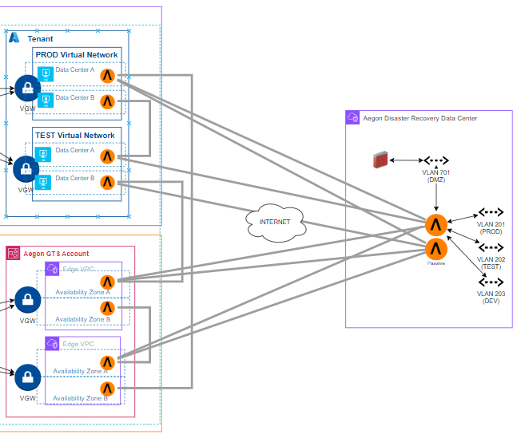

Observability
The Cloud Network Team has implemented custom monitoring and notifications using AWS Cloud native resources and visible in CloudWatch. There is currently no equivalent monitoring for Azure.
This project provides an automated network performance monitoring solution for AWS infrastructure across multiple regions. It measures DNS response times, network latency, and data transfer speeds through HTTP and S3 endpoints, publishing metrics to CloudWatch for analysis and alerting.
The tool runs as a serverless application using AWS Lambda and Step Functions to execute performance tests across development and production environments. It measures three key metrics: - DNS resolution time for critical endpoints - Network round-trip time (RTT) using TCP connections - Application-level throughput by copying test files via HTTP and S3 - All metrics are automatically published to CloudWatch for visualization and alerting
The monitoring system executes network performance tests through a coordinated flow of AWS services, transforming raw measurements into CloudWatch metrics.
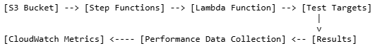
Key component interactions:
- Step Functions retrieves test configurations from S3
- Lambda functions execute in specified VPCs
- Tests measure DNS, network, and application performance
- Results are transformed into standardized metrics
- CloudWatch stores metrics for visualization and alerting

Authentication and Authorization
Access to all portals and infrastructure is controlled using credentials in Active Directory, CyberArk, Cisco ISE and AWS STS Assume Role capabilities.

Security Boundaries

Security Boundaries Diagram
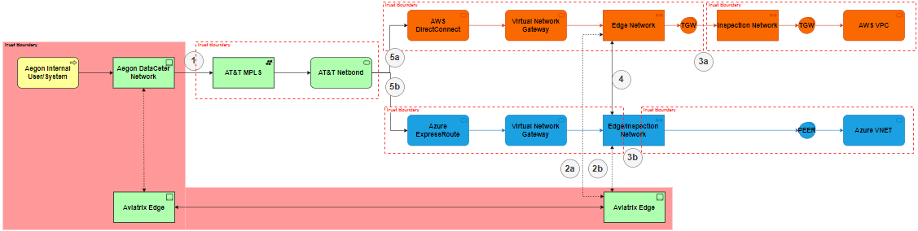

Security Boundaries Table
Security Boundary Reference |  | Existing Pattern | Description
1 | WAN Connection | WAN | BGP Peering and Pre-share key
2a | Aviatrix Connection to Azure | Intra-VPC | Encrypted traffic dropped into VPC and routed through Inspection Firewalls
2b | Aviatrix Connection to AWS | Intra-VNET | Encrypted traffic dropped into VNET and routed through Inspection Firewalls
3a | VPC Traffic Inspection | Inspection | Inspection of traffic flowing through VPC
3b | VNET Traffic Inspection | Inspection | Inspection of traffic flowing through VNET
4 | Trusted Connection between Aviatrix Edges | Aviatrix Encryption | Trusted Connection between Aviatrix Nodes
5a | ATT to AWS (Virtualized and shared) | Crossover Connection | Direct connection between ATT and AWS
5b | ATT to Azure (Virtualized and shared) | Crossover Connection | Direct Connection between ATT and Azure

Security Review Outcomes
Text

Threat Model Assessment

Threat Model Assessment Service Request number: XXXXXXXXXX

Resiliency
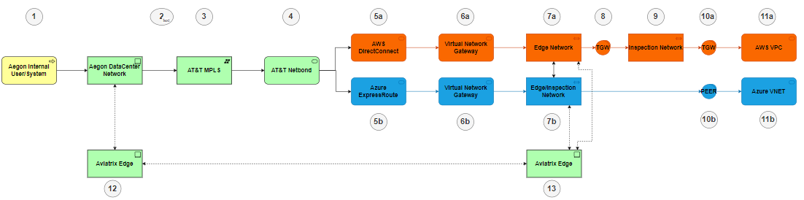
 | Components/Patterns Used | Comment | Resiliency
1 | N/A
2 | Local WAN/MPLS Circuits | Redundant Access and POPs; BGP used for Failover | Active/Passive
3 | MPLS Network Backbone | Redundant POPs and AT&T Backbone | Active/Active
4 | AT&T Netbond Cloud Virtual Network | Redundant Virtual Networks provisioned over  Redundant Cross-Connects to the CSP  BGP is used for Failover | Active/Passive
5a | AWS DirectConnect | Redundant DX Gateway connections in a single hosting facility with 99.9% SLA | Active/Active
5b | Azure ExpressRoute | Redundant XR Gateway connections in a single hosting facility with 99.9% SLA | Active/Active
6a | AWS Virtual Network Gateway | Redundant VGW using multiple AZs in the region  BGP is used for Failover | Active/Passive
6b | Azure Virtual Network Gateway | Redundant VGW using multiple data centers in region  BGP is used for Failover | Active/Passive
7a | AWS Edge VPC | Redundant Aviatrix Appliances in a multi-AZ VPC  BGP is used for Failover | Active/Passive
7b | Azure Edge and Inspection VNET | Redundant Aviatrix Appliances  Redundant Palo Alto Appliances  BGP is used for Failover | Active/Passive
8 | AWS Transit Gateway | Redundant AWS-managed gateway | Active/Active
9 | AWS Inspection VPC | Redundant Aviatrix Appliances  Redundant Palo Alto Appliances  BGP is used for Failover | Active/Passive
10b | Azure VNET Peering | Redundant Azure-managed Peering gateway | Active/Active
11a | N/A
11b | N/A
12 | Aviatrix Edge Physical Appliance | Redundant Aviatrix Appliances  Redundant Network Switches  Redundant WAN Edge Switches  BGP is used for Failover | Active/Passive
13 | Aviatrix Edge Virtual Appliance | Redundant Aviatrix Appliances  Multiple AZs  BGP is used for Failover

Data Solution

Data Classification
Data Confidentiality Classification |  | Data Legal and Regulatory Classification
☐ | Strictly Confidential | ☐ | Financial Information
☐ | Confidential | ☐ | Personal Identifiable Information
☐ | Internal | ☐ | Protected Health Information
☐ | Public | ☐ | Payment Card Information
☒ | No Data Shared | ☒ | No Personal Data Shared

This solution transmits data between two resources within our private network without storing or processing sensitive/personal data. It ensures seamless application functionality within the security architecture but does not replace application security. While it includes components for privacy and encryption of data in transit, it is not a substitute for secure transmission protocols or application-level encryption. The solution has no visibility into the classification of the data; it's simply "data".

Privacy Impact Assessment (PIA)
Text

Data Encryption
Data in transit is encrypted when leaving the control of a network managed by Aegon. For the purposes of this requirement, the Data Centers, DR Facilities, Azure VNETs and AWS VPCs are considered private and managed by Aegon. This also includes all Azure/AWS infrastructure used to provide communication between VNETs, VPCs and Data Centers.
Encryption of traffic on the MPLS and ExpressRoute/DirectConnect circuits is provided with an overlay network using Aviatrix.

Data Retention
There is no Aegon data stored and needing a retention policy. There is IaC that is stored in Github and backed up through the GitHub service. Aviatrix configurations are backed up in S3. There is no firm retention policy, but the configurations are maintained for 30 days as an immutable record of change activity.

Data Residency
There is no data residency requirement. The network is built to allow the business to define and implement a data residency plan.

GenAI (Future v.3)
N/A

Service Model
MPLS is supported by the Network Operations Team
Aviatrix Edge is supported by the Cloud Network Team
AT&T NetBond is supported by the Cloud Network Team and Network Operations Team. The SLA is documented here. The minimum SLA for the Virtual Network Connections is 99.90%
Azure ExpressRoute Circuits are orchestrated under the control of the Cloud Network Team
AWS DirectConnect Circuits are orchestrated under the control of the Cloud Network Team
TGW and VNET Peering is orchestrated by Aviatrix automation under the control of the Cloud Network Team

Shared Responsibilities

RACI Chart

Key Activity, Milestone, or Decision | Business Units | Global Enterprise Architecture | Global Infrastructure Platform Engineering | Global Information Security Services | BISO
Application Security Governance
Own Application Security capability | I | C/I | C/I | R/A | C/I
Define and maintain (adoption) strategy | I | R/A | C/I | R/A | C/I
Communicate (adoption) strategy | I | C/I | C/I | R/A | C/I
Define and maintain roles & responsibilities | I | C/I | C/I | R/A | C/I
Align Security strategy with Business Objectives | I | C/I | C/I | R/A | C/I
Define and describe policies & standards | I | C/I | C/I | R/A | C/I
Define application security objectives | I | C/I | C/I | R/A | C/I
Architecture
Create Tooling Architecture | I | R/A | C/I | C/I | C/I
Arrange ARB approval | I | R/A | C/I | R/A | C/I
Tooling implementation & Maintenance

Define tooling requirements |  | C/I | R/A | C/I | C/I
Select tools |  | C/I | R/A | C/I | C/I
Arrange required budget for tooling licences |  | C/I | R/A | C/I | C/I
Arrange required budget for resources maintaining tools |  |  | R/A | C/I | C/I
Implement and maintain tools |  | C/I | R/A | C/I | C/I
Implement required integrations |  | C/I | R/A | C/I | R
Conduct license management |  | C/I | R/A | C/I | C/I
Implement required reporting |  | C/I | R/A | C/I | C/I
Automate manual and repeatable activities |  | C/I | R/A | C/I | C/I
Deliver standard pipeline scanning building blocks |  | C/I | R/A | C/I | C/I
Organise DevSecOps community sessions |  | C/I | R/A | C/I | C/I
Training, Education & Roll Out
Identify and deliver training capabilities |  | C/I | C/I | R/A | C/I
Conduct developer training |  |  | C/I | C/I | C/I
Conduct security officer training |  |  |  | C/I | R/A
Conduct security awareness sessions |  | C/I | C/I | R/A | C/I
Conduct DevSecOps assessment per BU |  | C/I | C/I | C/I | R/A
Deliver Improvement plan as outcome of DevSecOps assessments |  |  |  | C/I | R/A
Ensure sufficient time is available for vulnerability remediation |  |  |  |  | C/I
Check scanning reporting results |  |  |  |  | R/A
Escalate to management if right follow up on scanning results and reporting is lacking |  |  |  | C/I | R/A
Scanning and mitigation
Conduct scanning |  |  | C/I | C/I | R/A
Prevent and resolve software security issues |  |  | R/A |  | C
Request false positive or exception check if required |  |  | R/A |  | C/I
Judge outcome false positive or exception requests |  |  | C/I |  | R/A
Administer outcome in ServiceNow VR |  |  | C/I |  | R/A

Implementation Approach

Proposed level of coordination
ASK Service Request is used to initiate connectivity (Network Consulting or Cloud Network Consulting). New connectivity over Netbond/ExpressRoute/DirectConnect will only be requests when there is a need to establish a new cloud region.

Dependencies

Licensing
MPLS is licensed under a network contract with AT&T
NETBOND is licensed under a cloud services contract with AT&T
Aviatrix is licensed under a contract with Aviatrix

Artifacts
Review Process and Acknowledgements
In Scope | Owner | Non-Architecture Review / Assessment Process | Point of Contact | Link to Acknowledgement or Evidence
☐ | Internal Compliance & Controls | Technology Risk Assessment (only for Core and Common designs) | Rachel Singewald | Link
☐ | GTS – Information Security | Information Security Review (process in development and will replace security review section) | Nick Russel, Chad Hunter, or Jeff Bain | Link
☐ | GTS – Information Security | Threat Model | Paul Nickelson, Jeff Bain | Link
☐ | Data Privacy | Data Privacy Impact Assessment (OneTrust) | Adam Kaminski | DPIA Number
☐ | GTS - Architecture | Approved Architectural Artifacts Added to Architecture Repository | Assigned Architect | Link to Repo

Waivers and/or Exceptions
GTS Architecture Review Board (ARB) provides a governance framework for Architecture Risk. The GTS ARB will review and approve/reject solution Architecture Exceptions.
See this link for documentation related to Exceptions to Standards.
<start of excerpt from the above document>
The GTS ARB holds the responsibility for ensuring that risk acceptances and/or risk remediations for exceptions to standards are approved and documented within architecture templates before granting GTS Final ARB approval. The assigned architect is responsible for memorializing the GTS Risk Acceptances and GTS Risk Remediations within the Waivers and/or Exceptions section of the architecture template that is being presented for GTS ARB approval.
Risk Acceptance and Risk Remediation compliance is a function of the GTS internal risk management process. Exceptions to standards are logged as GTS Risk Acceptances or GTS Risk Remediations.
- GTS Risk Acceptances are logged for exceptions to standards that are not planned to be remediated. GTS Risk Acceptances will be reviewed annually though the GTS internal risk process to ensure that the risk acceptance without remediation remains acceptable.
- GTS Risk Remediations are logged for exceptions to standards that are intended to be remediated. Risk remediations require a remediation plan with a remediation date that identifies the commitment to remediate the risk. GTS Risk Remediations are required to be remediated within 12 months.
<end of excerpt from the above document>

Risk Acceptances
# | Acceptance Title | Exception Description | Link to Risk Exception Acceptance
1
2
3

Risk Remediations
# | Remediation Title | Exception Description | Link to Risk Exception Remediation
1
2
3

Security Exceptions
# | Exception Title | Exception Description | Link to Security Exception
1
2
3

Estimated Costs

Financial Considerations
- AT&T MPLS
- AT&T Netbond
- Aviatrix
  - Virtual and On-Premises Appliances
- AWS DirectConnect
- Azure ExpressRoute

Non-Financial Considerations
N/A

Financial Assumptions
N/A

Resourcing Considerations
N/A

Exit Strategy
This design is a collection of different solutions. Replacing any individual component will require looking at the intersections with the other products. Aviatrix is needed for Encryption and low-latency inter-cloud connectivity. MPLS and Netbond have alternatives from other carriers (LUMEN) and from provides like Equinix, Megaport.
Migrating to a new architecture is a multi-year effort.

Appendix A: Architecture Review Board Scorecard
<link to scorecard>

Appendix B: Related Documents
Aviatrix: ERM000001750061-ACBSD-934-Cloud segmentation and Control - Solution Design v1.0.docx
Inspection VPC/VNET: ERM000001750061-ACBSD-934-Cloud segmentation and Control - Solution Design v1.0.docx
AT&T NETBOND: ERM000001750061-ACBSD-934-Cloud segmentation and Control - Solution Design v1.0.docx
AWS DirectConnect: ERM000001750061-ACBSD-934-Cloud segmentation and Control - Solution Design v1.0.docx
ExpressRoute: ACBSD-3278-Azure ExpressRoute.docx
AWS Transit GW: RITM0937831-ACBSD-3229-AWS Transit Gateway Component Standard.docx
MPLS

Appendix C: Glossary of Terms and Acronyms

